

SCSR2213 NETWORK COMMUNICATIONS
Session: 2025-2026-II
Task#1: Project Setup
Group: Hub
SECTION: 1
Lecturer: Dr. Adnan Khalid
Name | Matric Number
MOHAMMED MOHSEN MOHAMMED ALSAKKAF | A23CS4026
ABDULRAHMAN ABDO AHMED SULTAN | A24CS4057
MOHAMMED OSAMA MOHAMMED NOUR ELSEDDIG | A25CS4077

Table of Contents
1. Introduction 3
2. Explanation for the Floor Design: 4
3. Floor Plan Design 5
1. Ground Level Floor Plan 5
i. First Level Floor Plan 6
ii. Hybrid Classroom 7
iii. Video Conference Room 8
iv. Student Lounge 9
v. Cisco Lab 10
vi. Embedded Lab 11
vii. General Lab 12
4. MEETING 13
5. ATTENDANCE 13
6. MINUTES 14
7. Projected Marks 15

Introduction

This is the first project task for Team Hub. We are focusing on building a functional network for a fresh, two-floor facility in the Faculty of Computing that features high-tech computer labs and specialized video meeting rooms. We are using tools like Draw.io to create an efficient floor plan that makes the most of the available budget while allowing for simple maintenance and easy growth as the faculty expands over time. Our primary mission involves making a solid foundation for the network infrastructure that keeps data safe and helps the department achieve its operational goals with high-speed performance and reliability.
Looking at the layout, we have included a ground floor with essential spots like the server room and academic offices, while the upper floor contains four labs—each having thirty individual workstations—alongside a relaxing student lounge that has a piano and copier. Each team member took on different roles, such as designing specific floors and managing meeting minutes, to ensure our final product is highly detailed and professional for this project setup phase. We believe that combining our group’s technical skills and strong teamwork will result in a design that handles the current demands of the students while anticipating what they might need in the future. The success of our work depends on providing a readable and labeled floor plan that includes a hybrid learning space and lecturer offices to create the perfect environment for both staff and students in the faculty.

Explanation for the Floor Design:
The brand new faculty building design is split across two levels to create a professional learning space for students and faculty staff alike On the first floor we placed work area one as a hybrid classroom and work area two for video conference meetings while also providing a spacious student lounge for relaxation and study breaks This level includes separate prayer rooms for both males and females along with clean restrooms and wide hallways to allow everyone to move around comfortably and safely during busy hours Between the classes our design ensures that social spaces and religious areas are easily accessible to provide a good balance for everyone inside the building
Our second floor is the technical hub of the facility and features four main academic laboratories known as general lab one and general lab two plus a cisco lab and an embedded lab To meet the project requirements each of these four laboratories is equipped with exactly thirty individual workstations and specialized desk areas for high tech networking gear We placed all the computer labs together on this upper floor to simplify the cable management and network infrastructure which makes maintenance easier for the technical team Our team focused on a smart layout that prioritizes high speed connectivity for the labs while keeping the environment organized and readable for future expansion needs

Floor Plan Design

Ground Level Floor Plan
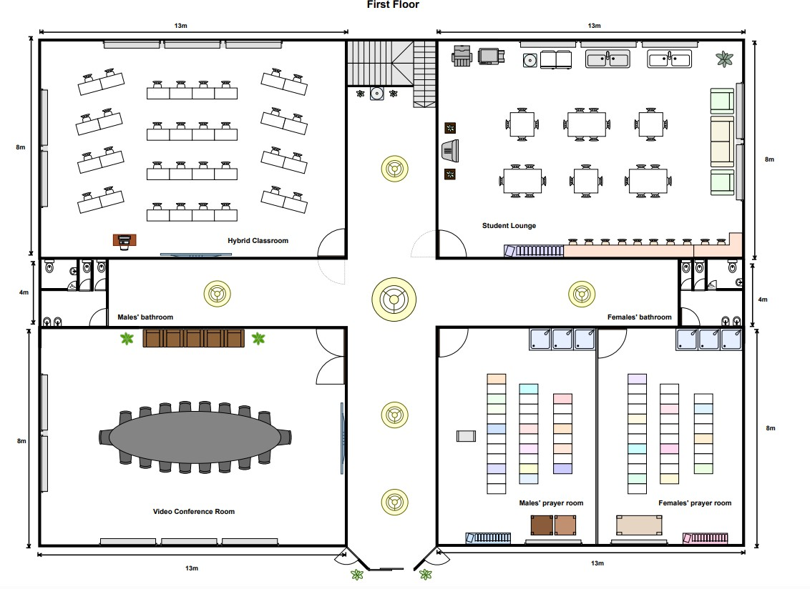
Figure 2.1 Ground Level Floor Plan

The ground floor includes the Hybrid Classroom, Video Conference room, Student lounge, male and female prayer rooms, and male and female bathrooms. The layout is designed to support both learning and collaboration, providing flexible spaces for teaching and group discussions. The hybrid classroom and video conference room are positioned for easy access and efficient network connectivity, while the student lounge offers an open area for relaxation and study with wireless access. The placement of the prayer rooms and bathrooms ensures convenience and accessibility for all users.

First Level Floor Plan

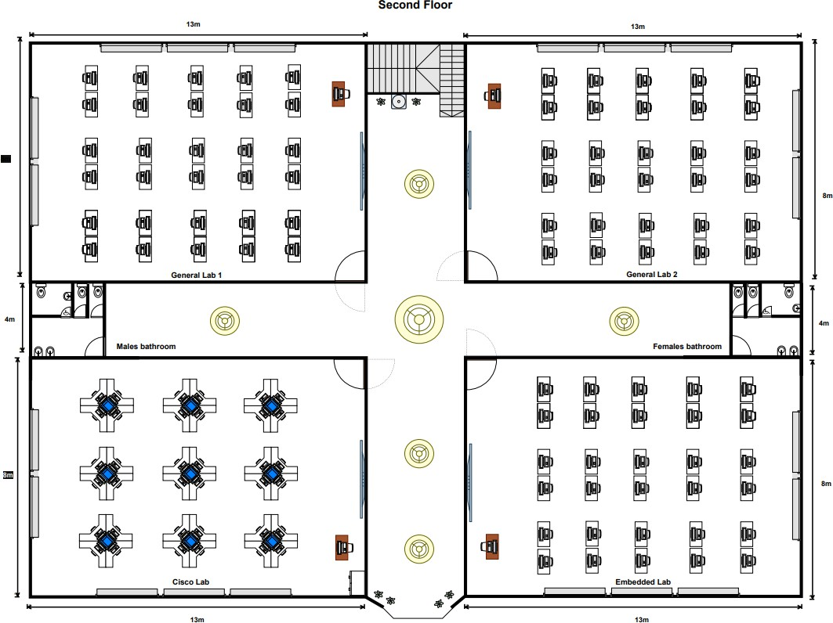
figure 2.2 First Level Floor Plan

The first floor consists of General lab 1, General lab 2, the Cisco lab and Embedded lab, along with male and female bathrooms. The labs are arranged to allow smooth traffic flow and efficient cabling between rooms. The Cisco lab is located for specialized networking activities, and the Embedded lab is set up for IoT and sensor-based experiments. Both General labs are designed for flexible use, suitable for various computing courses. This layout ensures a practical learning environment with sufficient space for a minimum of 30 workstations per lab and supports future network expansion.

Hybrid Classroom
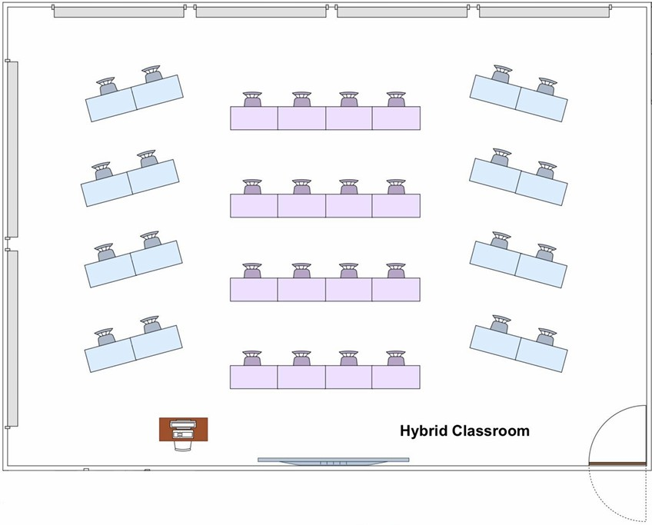
figure 2.3 Hybrid Classroom Floor Plan

The hybrid classroom supports both physical and virtual learning. It is equipped with video conferencing systems, interactive smart boards, wireless microphones and high-speed internet connectivity. This setup allows the lecturer to conduct face-to-face sessions while simultaneously connecting with remote participants. The design ensures high audio-visual quality and comfortable seating arrangements to enhance the teaching and learning experience.

Video Conference Room

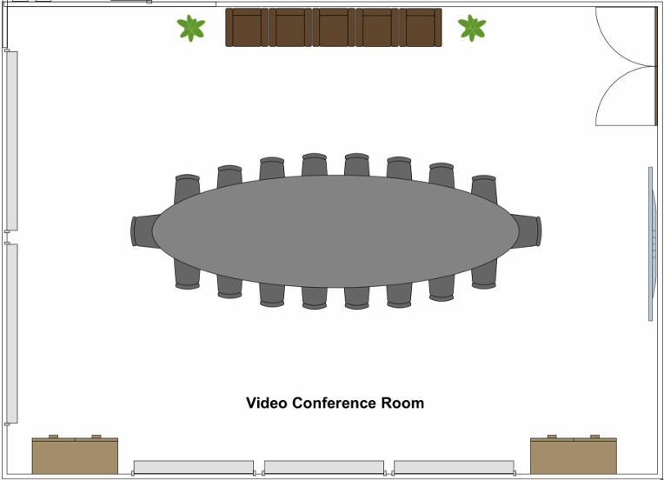

Figure 2.4 Video Conferencing Room Floor Plan

The video conference room is built for virtual meetings, presentations and collaborative sessions. It includes high-definition cameras, conference microphones, a large display screen and reliable network connections. The room supports communication between staff, students and external partners, promoting remote project coordination, and academic discussions.

Student Lounge

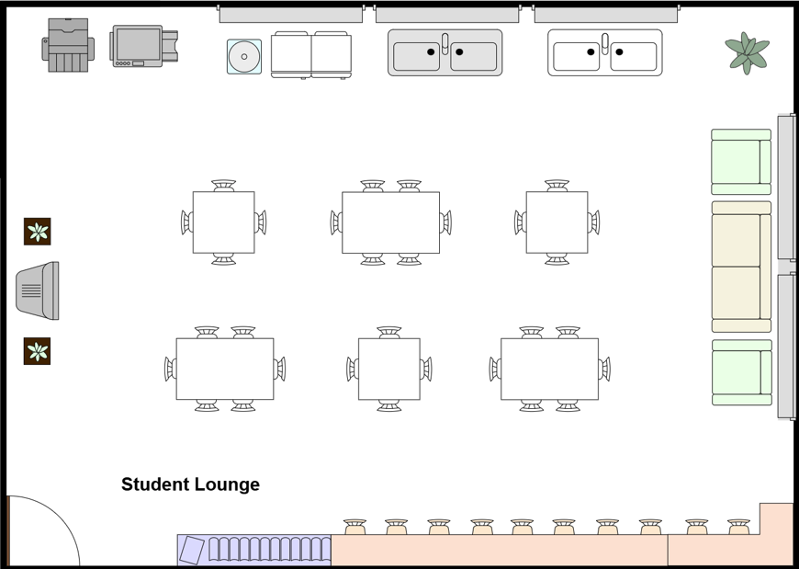
figure 2.5 Student Lounge Floor Plan

The student lounge provides a comfortable space for students to study, collaborate or relax. It is equipped with Wi-Fi access, charging ports and comfortable seating. The design encourages a social yet productive environment where students can engage in group discussions or individual work while staying connected to the faculty’s network.

First Floor - Cisco Lab
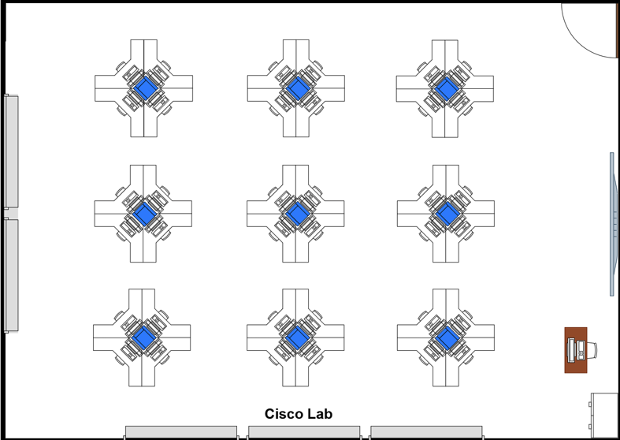
figure 2.6 Cisco Lab Floor Plan

The Cisco Lab is designed for network configuration, troubleshooting and implementation training. It includes 36 computer workstations, 9 Cisco routers and switches, patch panels and structured cable systems to support hands-on networking activities. The lab is equipped with high-speed wired connections and secure access points for real-time simulation and testing. This setup supports the faculty’s goal of preparing students for professional networking certifications and 4IR-related technologies.

First Floor - Embedded Lab
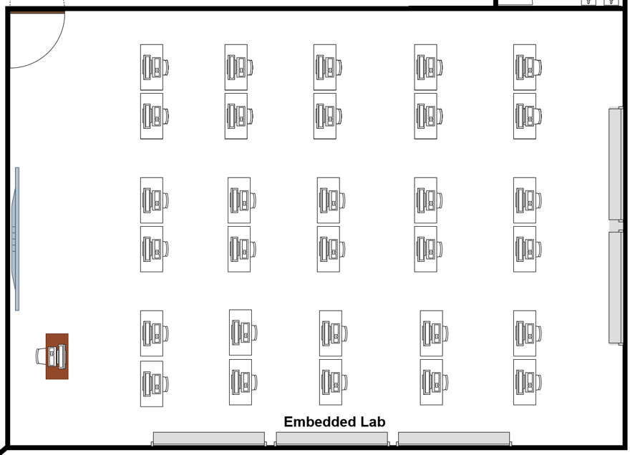
Figure 2.7 Embedded Lab Floor Plan

The embedded lab focuses on IoT, digital systems, and sensor-based projects. It is equipped with development kits, microcontrollers, testing instruments and computers connected through a stable local area network. The lab provides both wired and wireless connectivity to allow students to integrate hardware and software systems efficiently. The arrangement ensures enough workspace for hardware setup and prototype testing.

First Floor - General Labs

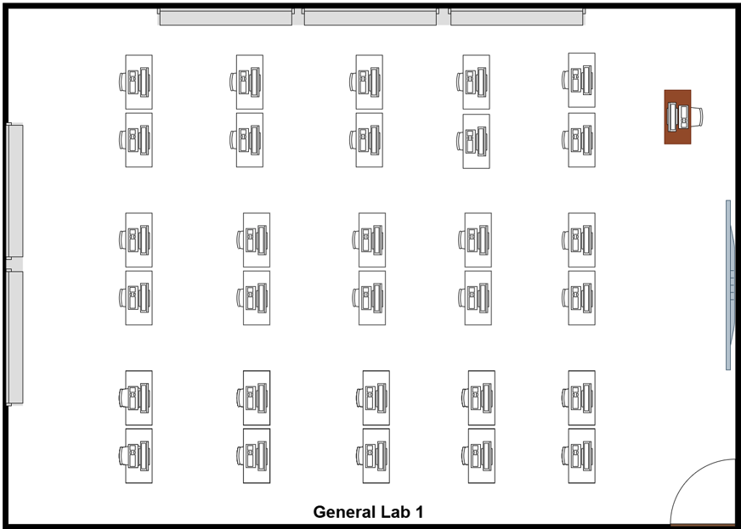
Figure 2.8 General Lab 1 Floor Plan
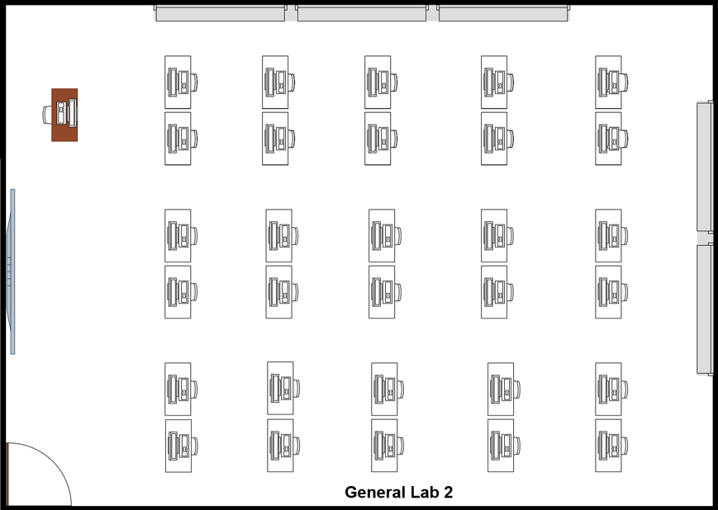
Figure 2.9 General Lab 2 Floor Plan

The two General labs are designed for regular computing classes, programming and software-based learning. Each lab contains 30 computer workstations, projectors, network switches and Wi-Fi access. The layout allows easy movement and clear visibility for both students and instructors. The network infrastructure ensures high-speed internet access for online learning, research, and lab exercises.

MEETING
Date | 1/4/2026
Location | N28
Agenda | Discussion of project task 1  Task distribution for each member  Discussion of group name
Meeting MC | Mohammed Alsakkaf

ATTENDANCE
Name | Time | Reason of absent
Mohammed Alsakkaf | 5:00 pm | -
Abdulrahman Abdo | 5:00 pm | -
Mohammed Osama | 5:00 pm | -

MINUTES

No | Item Discuss | Idea/suggestion | Person in charge
1. | Group name | Group name decided to be “Hub”. | Mohammed Osama  Mohammed Alsakkaf
2. | Tools or software use to design the floor plan | Website “Draw io” decided to be used after discussion. | Mohammed Osama  Mohammed Alsakkaf  Abdulrahman Abdo
3. | Floor plan design | Mohammed Osama  and Abdulrahman designed the floor plan.  Mohammed Alsakkaf volunteered to draw for the ground floor and, Mohammed Osama  volunteered to draw for the first floor. | Mohammed Osama  Mohammed Alsakkaf  Abdulrahman Abdo
4. | Directory of floor | Abdulrahman and Mohammed Alsakkaf volunteered to complete the directory of floor. | Abdulrahman Abdo  Mohammed Alsakkaf
5. | Next meeting | 01/4/2026 - to gather everything
6. | Meeting ended | 6:00pm

Projected Marks
TASK 1
ITEM | MARKS | EXPECTED MARKS
Group name & Members
Suggested floor plan.
Fit description – as per case
study provided.
A total of 30 workstations and
other equipment planned for
each lab
Scale: with scale
Clear and readable. Has
appropriate labels
Creativity
TOTAL

